**Data 620 Week 2 Assignment 1**

Enron Email Network Dataset Summary

The Enron Email Network dataset contain 36,692 nodes. The summary statistics are as follows:

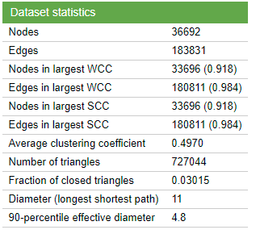

**Project Resources:**

GitHub Repository: <https://github.com/tagensingh/DATA620-W2-A1>

Jupyter Notebook: <https://github.com/tagensingh/DATA620-W2-A1/blob/main/W2-A2-ENRON.ipynb>

Gephi Project File: <https://github.com/tagensingh/DATA620-W2-A1/blob/main/data620_gephi_w2_a2.gephi>

Dataset Source:

J. Leskovec, K. Lang, A. Dasgupta, M. Mahoney. [Community Structure in Large Networks: Natural Cluster Sizes and the Absence of Large Well-Defined Clusters](http://arxiv.org/abs/0810.1355). Internet Mathematics 6(1) 29--123, 2009.

B. Klimmt, Y. Yang. [Introducing the Enron corpus.](http://ceas.cc/2004/168.pdf) CEAS conference, 2004.

Collaborators:

Ramnivas Singh

Deepak Sharma

Tage Singh

**Data subset – 500 records**

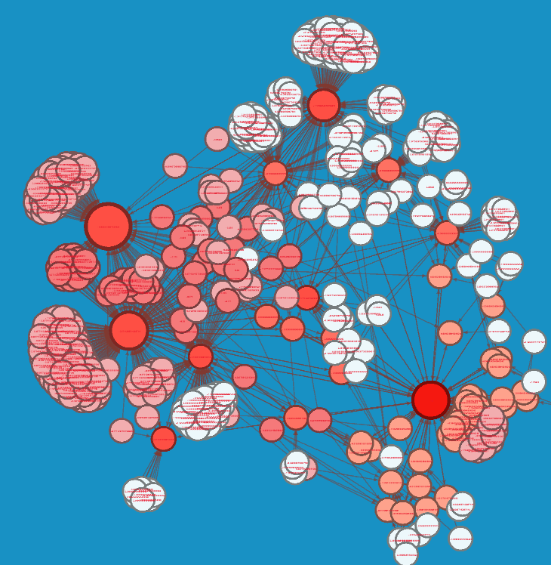

Eigenvector Centrality Report

Parameters:

Network Interpretation: undirected  
Number of iterations: 1000  
Sum change: 3.1820143115450007E-4

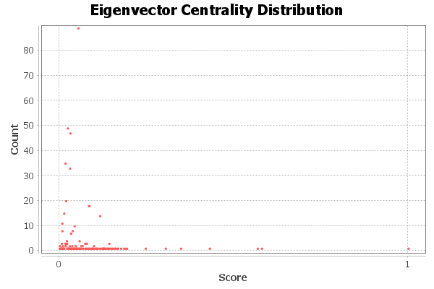

Graph Distance Report

Parameters:

Network Interpretation: undirected

Results: Diameter: 4  
Radius: 2  
Average Path length: 2.871765568397447

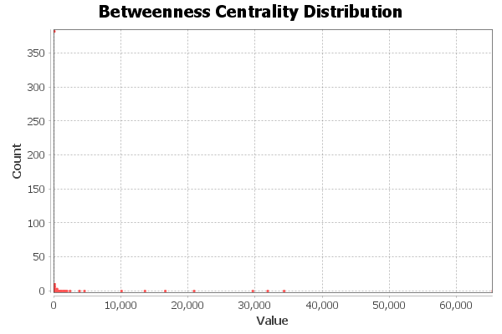  
  
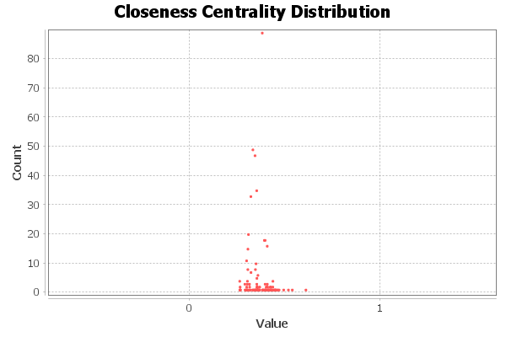

**Data subset – 1,000 records**

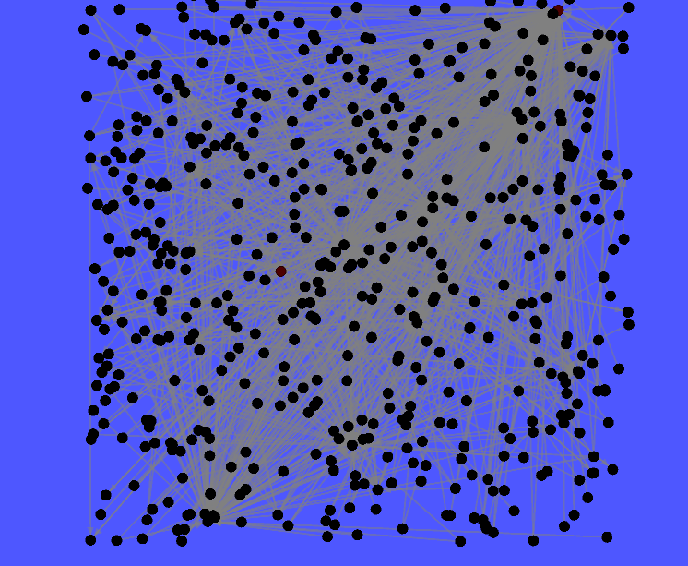

Eigenvector Centrality Report

Parameters:

Network Interpretation: undirected  
Number of iterations: 1000  
Sum change: 3.1820143115450007E-4



Graph Distance Report

Parameters:

Network Interpretation: undirected

Results:

Diameter: 4  
Radius: 2  
Average Path length: 2.871765568397447

  
  
